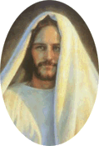

"Without Christ, there can be no fullness of joy."

~ President Ezra Taft Benson ~

