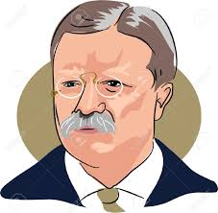

“Do what you can,
with what
you have,
where you are.”

Theodore Roosevelt

