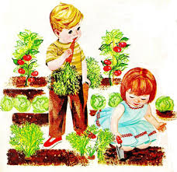

“With the arra With the arrival of spring, we hope all of you will put in you will put in your gardens and prepare to enjoy their pr enjoy their produce this summer.

We hope you are making this a family affair, with everyone, even the little ones, assigned to something.

There is so much to learn and harvest from your garden, far more than just a crop itself.”

President Spencer W. Kimball, April 1978 General Conference