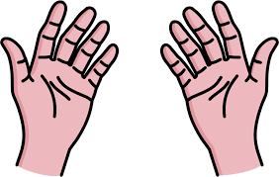

“Hands
that work
are more blessed
than Lips
that pray.”

Howard W. Hunter

