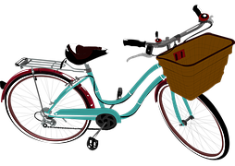

"Life is like
riding a bicycle.
To keep your balance, you must
keep moving."

Albert Einstein

