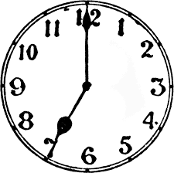

“Never underestimate
the value
of 15 minutes.”

