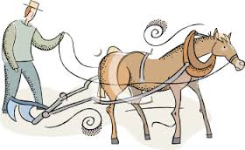

“Pray for a good harvest
-----but keep plowing.”

