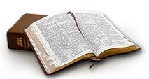

"Prevent truth decay.
Brush up
on your scriptures."

