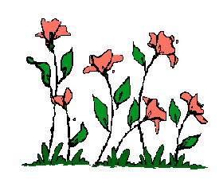

“One life
can influence
an entire community,
just as a flower
can fill a room
with sweet perfume.”

