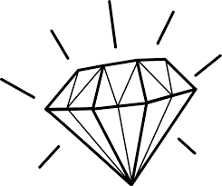
“The short sayings of wise
and good men
are of great value, like the dust
of gold
and the sparkle
of diamonds.”

Tillotson

