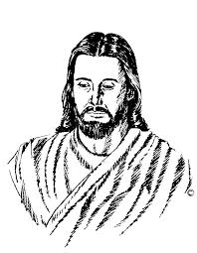

All God's testings
have a purpose, Someday you will
see the light.

But for now,
just put your trust
in Him:
Walk by faith,
not by sight.

