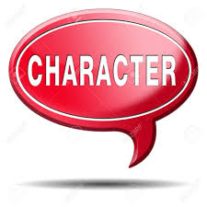
"Character
is a victory--
not a gift."

