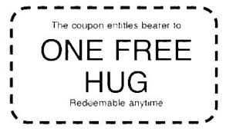

“A hug is the perfect gift--
one size fits all, and nobody minds if you exchange it”

Ivern Ball

