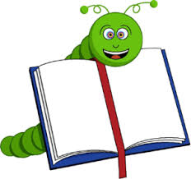

"A book
is a present
you can open
again and again."

