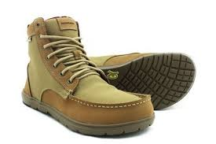

"Be sure you put your feet
in the right place,
then
stand firm"

Abraham Lincoln

