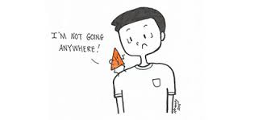

“A chip
on the shoulder
is the
heaviest load
a man
can carry.”

Anonymous

