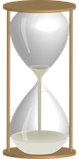
"My favorite
things in life
don't cost any
money.
It's really clear
that the most
precious resource
we all have
is time."
Steve Jobs

