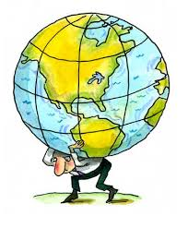

“Those who are
lifting the world
upward and onward
are those who encourage
more than criticize. “

