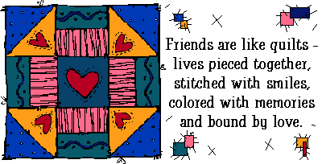

TODAY will never
come again...
Be a blessing.
Be a friend.
TAKE TIME
TO CARE.

