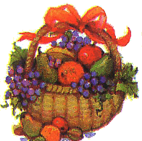
“Be someone who finds something good in each day---
Then give it to others.”

