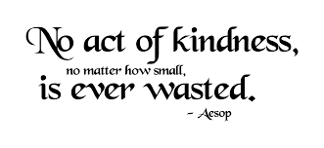

“Kindness
is the language
which the deaf
can hear
and the blind
can see.”

Mark Twain

