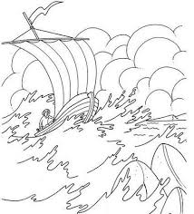
"To make decisions while infuriated
is as unwise
and foolish
as it is for a captain
to put out to sea
in a raging storm."

ElRay L. Christiansen

