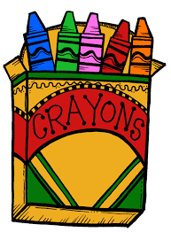

“We could learn a lot
from crayons:
some are sharp,
some are pretty,
some are dull,
some have weird names,
and all
are different colors....
but they all
exist very nicely
in the same box.”

