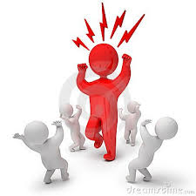
“You can stand tall without standing
on someone.
You can be
a victor
without having victims.”

Harriet Woods

