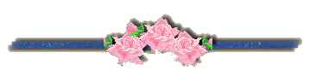

“Allowing an unimportant mistake to pass without comment
is a wonderful social grace.”

Judith Martin

