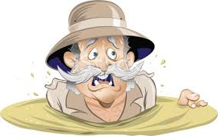

"We must never become so busy slapping
at mosquitoes
that we walk into the quicksand."

-Richard L. Evans-

