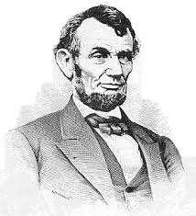

"I care not if God is on my side;
my constant hope and prayer
is that I may be found
upon God's side."

--Abraham Lincoln--

