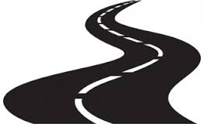

"There is no traffic jam
on the second mile."

