“I have a vision 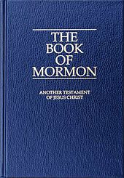
of thousands of missionaries
going into the mission field
with hundreds of passages memorized
from the BOOK OF MORMON
so that they might feed the needs
of a spiritually famished world.”

--Pres. Ezra Taft Benson, Gen. Conf., Oct., 1988--

