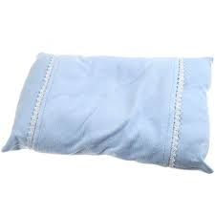
“There is no pillow
so soft
as a
clear conscience.”

--French Proverb--

