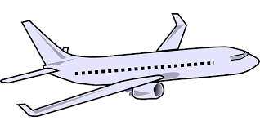

“When everything seems to be
going against you,
remember that the airplane takes off against the wind,
not with it.”

--Henry Ford--

