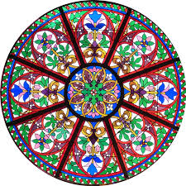

"People are like
stained glass windows.
They glow and sparkle
when it is sunny
and bright;
but when the sun
goes down
their true beauty
is revealed--
only if there is a
light from within."

