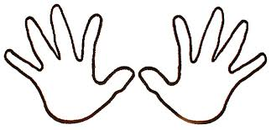

"Remember,
if you ever need
a helping hand,
you'll find one
at the end of your arm.
As you grow older,
you will discover
that you have two hands,
One for helping yourself,
the other for helping others."

