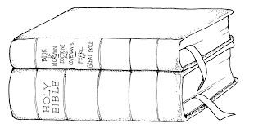

"Some have suffered death
to make it possible for us
to have the scriptures today.
At times laws even prohibited
the public or private reading of them.
What a marvelous blessing we have
to not only possess the most complete collection of scripture in history,
but also to have the freedom
to search and to use them!"

--Elder L. Lionel Kendrick--

