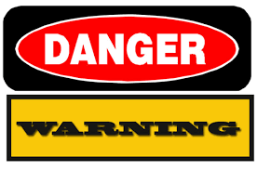

"Anger
is just a letter short
of DANGER."

