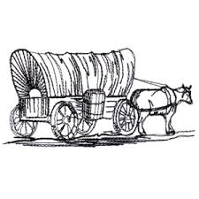 “As you read the history of the pioneers, it becomes increasingly clear with every page that you read, that they endured adversity and hardship. They could stand persecution; they could bear up under abuse; they could recover from the infliction of all kinds of harmful hatreds. That record is clear.
The question before our generation is: Can we and our children endure prosperity and ease? "I have not the time…to compare the two struggles. I sometimes wonder which is the harder.”

Elder Adam S. Bennion - April 1954 General Conference

