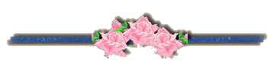
“Happiness
is a state of being content or satisfied.
But sometimes it’s hard to be content and satisfied—to have enough.
There will always be a newer watch, a more powerful computer, a fancier car.
But you can never get enough of what you don’t need, because what you don’t need never satisfies.
We spend money we don’t have to buy things we don’t need to impress people we don’t like who don’t come over and get impressed anyway.”

Mary Ellen Edmunds, BYU Speeches, 1995-96, p. 88

