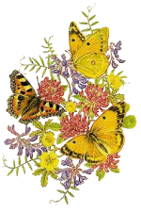
"The best things in life
are nearest:
Breath in your nostrils,
light in your eyes,
flowers at your feet,
duties at your hand,
the path of right just before you.
Then do not grasp at the stars,
but do life's plain, common work
as it comes,
certain that daily duties
and daily bread are
the sweetest things in life."

Robert Louis Stevenson

