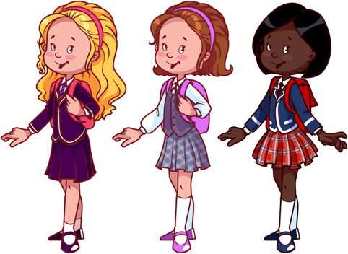
"A true friend
is somebody
who can make us do
what we can."

~R. W. Emerson~

